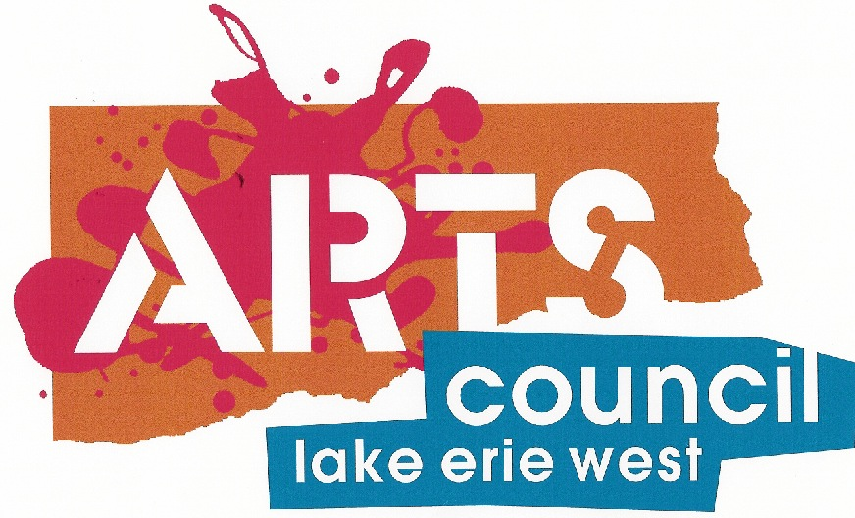

Common Space Center for Creativity
1700 N. Reynolds Road
Toledo, Ohio 43615
Ph: 419/531-2046 Fax: 419/531-5049

Seven Eagles Historical Education Center
P.O. Box 246 • 16486 Wapakoneta Road • Grand Rapids, Ohio 43522
Call: 419-290-0995 or email: martinnagy@aol.com

Web information: seven-eagles.com http://www.aclew.org
https://www.facebook.com/SevenEaglesEARTHCenterOfficial/

RESERVATION FOR PROGRAM:
I would like to have (please send me) a: Confirmation______ Map_______

Tour Date:___________________Times of Arrival__________Departure_____________
Group/School_______________________________________________________________
Contact Person______________________________________________________________
Address____________________________________________________________________
Phone: School.____________________Cell__________________Other________________
Email address(es) __________________________, ________________________________
Age/Grade Participants_____________ No.: Children___________ Adults__________
Rate Per: 1 Hour Tour $2.50 (add .50 if bringing lunch); 2 Hour Tour* $4.50 (most popular)
3 Hours* $6.00; 4 Hours* $7.50; 6 Hours8 $10.00; Small Groups: $75.00/hr minimum
*Actual tour length; includes 1 hour additional time for lunch/games (i.e. allow 3 hours for 2 hour tour)
Tour Program Overview – general program focuses on Woodland Natives and Pioneers.
Special Interest Areas (note below any special coordination with curriculum):
Woodland Indians____________________________________________________________
Includes: Clothing Cooking/Foods Crafts Games Hunting

Frontier settlement___________________________________________________________
Include: Travel Cooking Crafts Games Clothing

Extras/Highlights:____Tomahawk _____Dbl. Ball; ______Canoes;* _____Fishing**
*canoes require extra adult chaperones & appropriate weather conditions
**fishing requires appropriate weather conditions (bring grubs or small worms)

Trading Post Visit after lunch/games: ____Yes ____No We have assorted feathers,
bamboo flutes, whistles, tops, rubber tomahawks, beads, arrowheads, etc. ranging .05 to $3.00 average.

MAKE & TAKE IT –extra charge to cover material cost, allow approx. 45 minutes extra
Rabbit Fur Pictographs (when available $6--$10) @ $ .00 student_____________
Arrowhead & Bead Necklace @ $2.50 student_____________
Weaving with hand loom, natural objects @ $3.00 student_____________
Feather Quill Pen, Ink & Parchment paper @ $3.00 student_____________
Any other requests/notes:

